AGILE 2.0 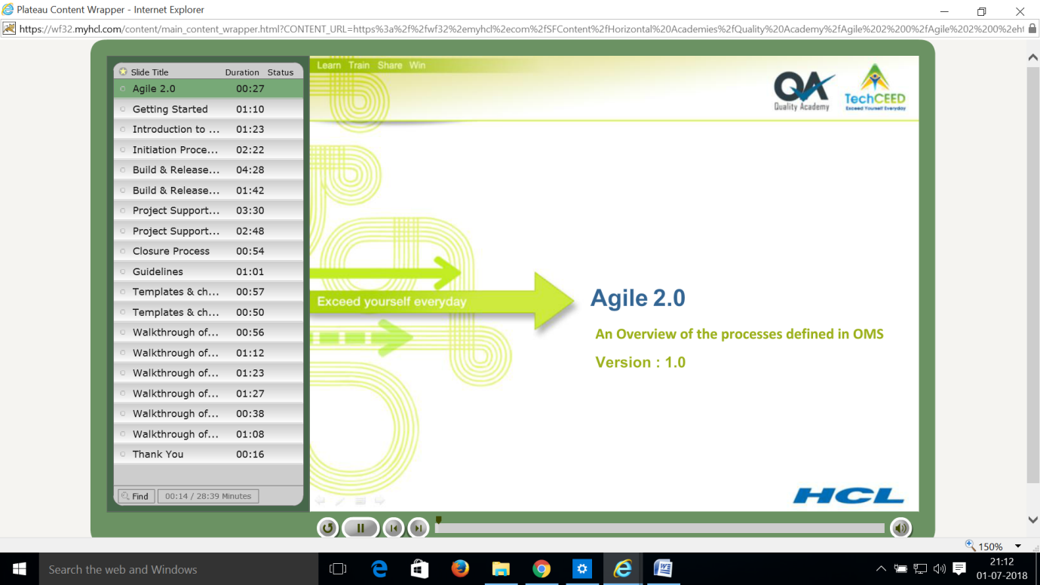

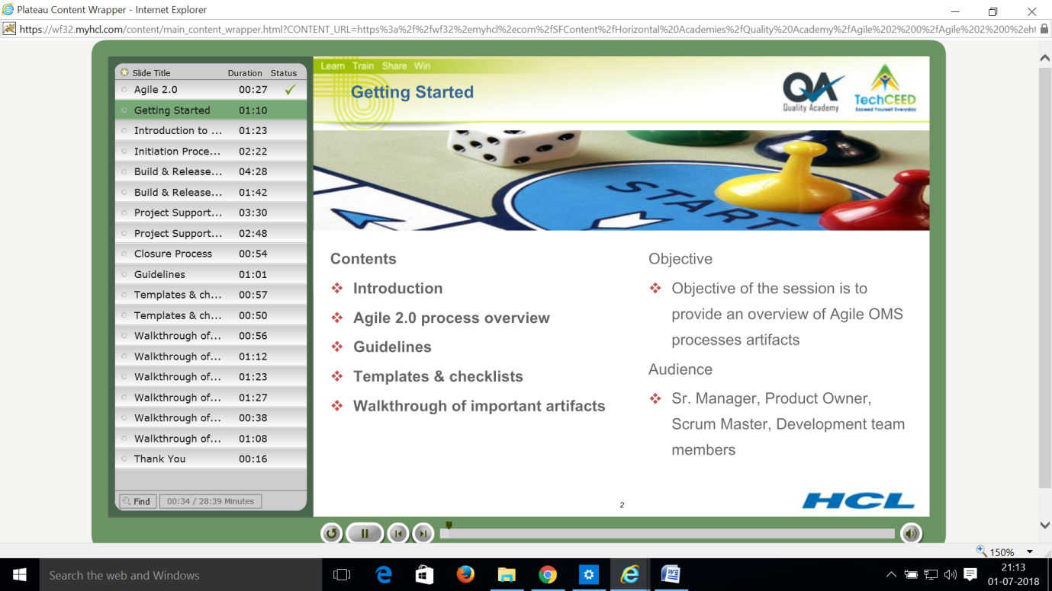

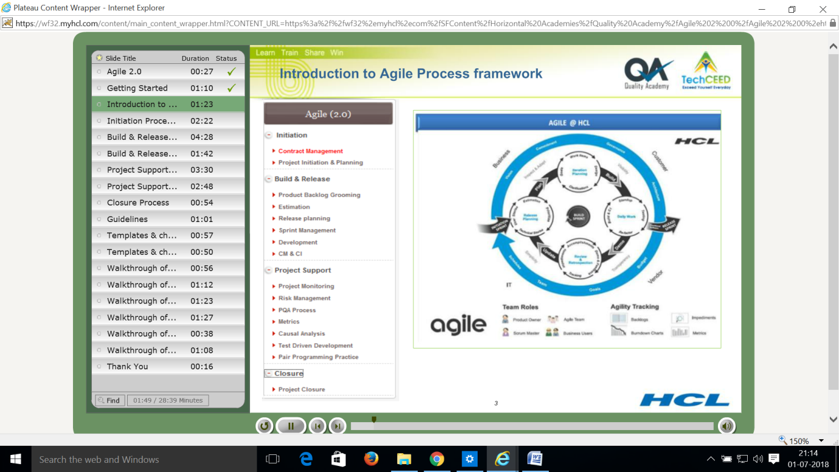

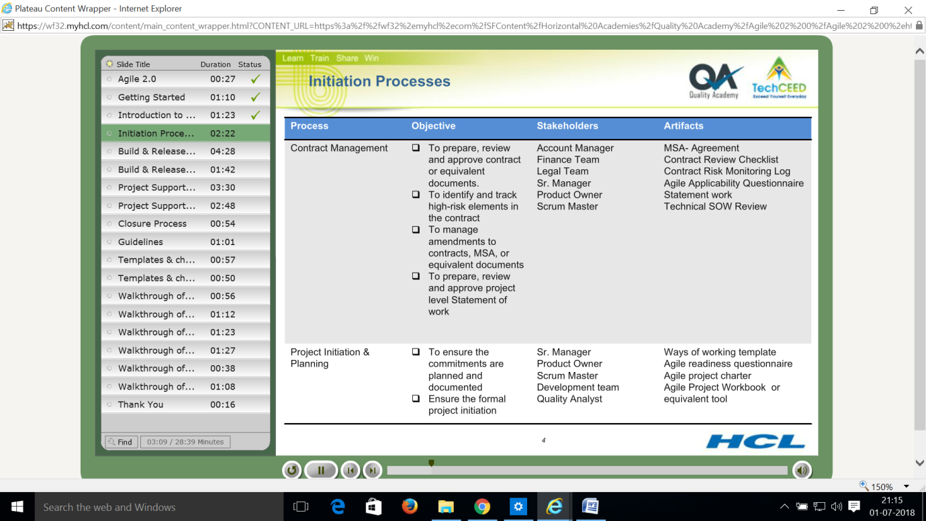

**BUILD AND RELEASE PROCESS – Slide 6**

**Product backlog grooming – Artifacts**

Prioritized updated backlog

Business story card

**Estimation – Artifacts**

Planning poker

Estimation workbench

SSS estimation

**Release planning – Artifacts**

Release plan updated in Agile project workbook or equivalent tool

**Sprint Management – Artifacts**

Sprint workbook, sprint management checklist, impediments log, DOD checklist, potentially shippable work products, filled sprint retrospective sheet and action items

**Development – Artifacts**

Traceability matrix, business story card, technical story card, source code, automated unit test scripts, automated test cases, test log, review log

**CM and CI – Artifacts**

Successful CI builds, agile project charter updated with CM CI planning, change impact analysis form for FPP projects

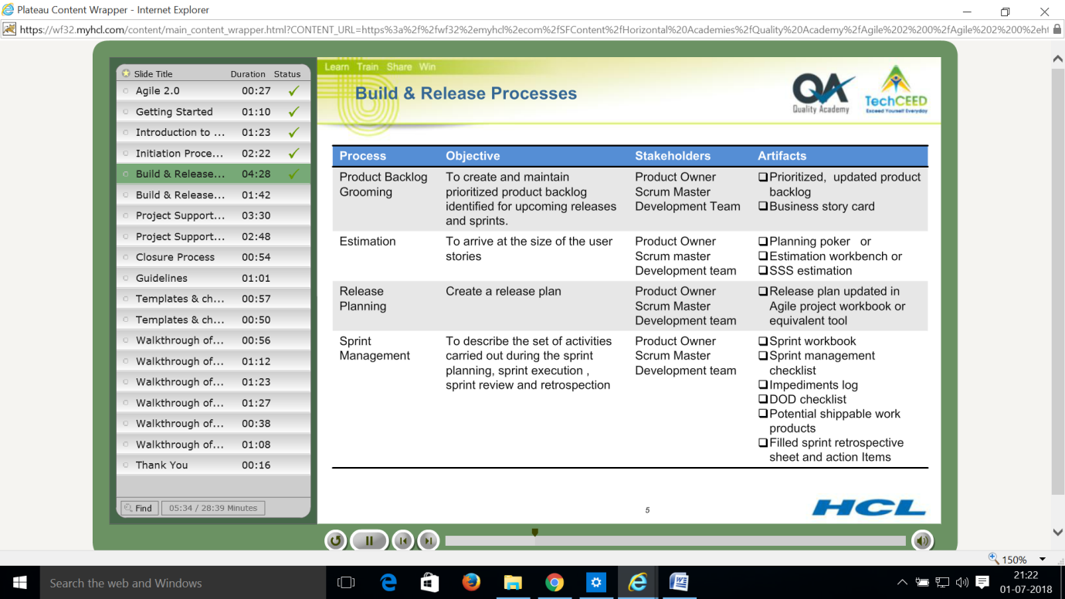

**Project Support processes – Artifacts – Slide7**

1. **Test Driven development - artifacts**

Unit test cases, source code

1. **Pair programming - artifacts**

Source code, working software ready for demo

1. **Project monitoring - artifacts**

Agile project workbook, Sr. Management review, CAPA form

1. **Risk management - artifacts**

Risk management through agile project workbook or tool, risk identification checklist

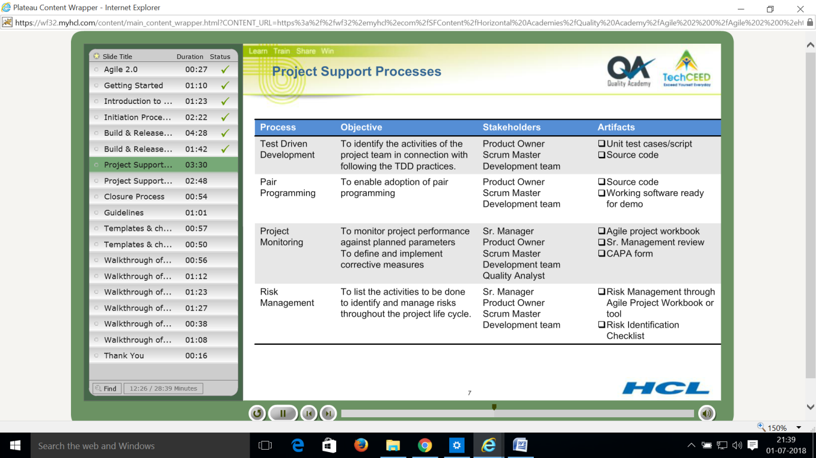

**Project Support processes – Artifacts – Slide8**

1. **Project quality assurance - artifacts**

Filled in PCI report

To facilitate the team on agile OMS processes

To objectively evaluate the performed processes against the applicable process

Descriptions

To communicate the non-compliance issues and track them to closure

1. **Metrics - artifacts**

Metrics workbook

Specifying the metrics, data collections, storage mechanisms, conduct analysis od data

of data at project level

1. **Causal analysis - artifacts**

Project charter updated with causal analysis approach, CAR form with action plan

To define the process for capturing and analysing the customer found defects, major internal defects and issues.

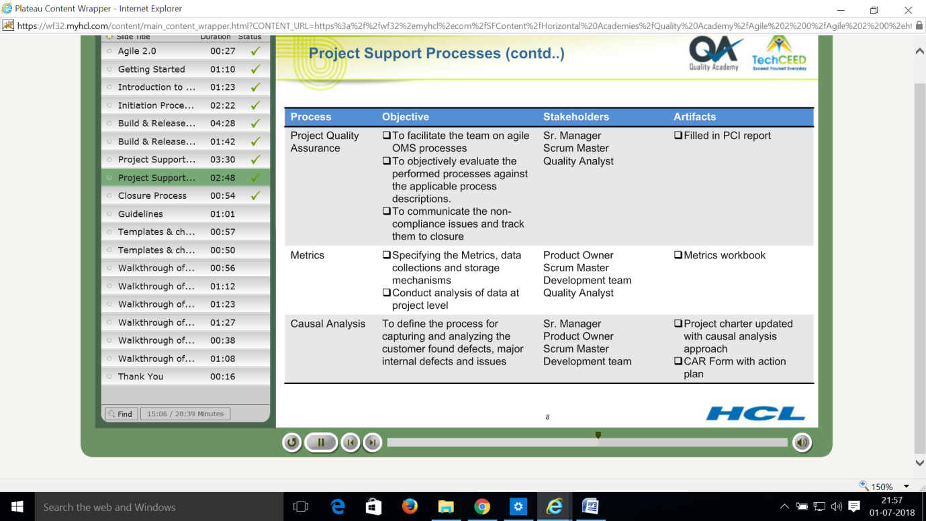

**Closure process** – Slide 9 – Artifacts

Project case study

Collect inputs for process improvement through project final or virtual closure activities for sharing across the organisation

Archiving product and process data

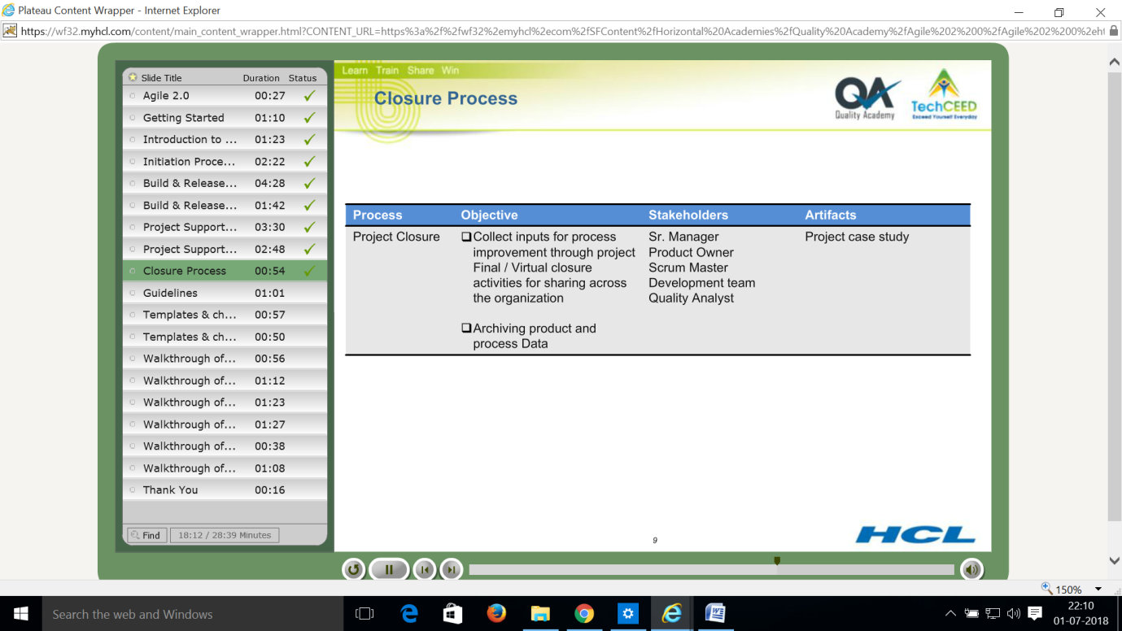

**Guidelines - Slide 10**

CAR guideline **–** casual analysis guideline

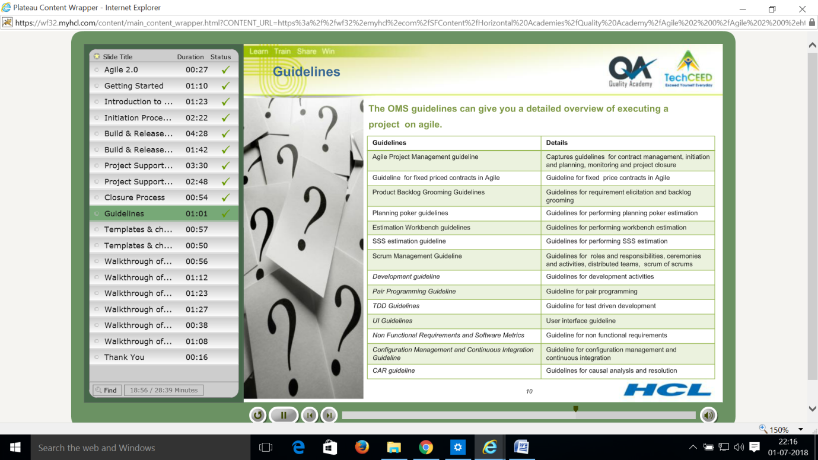

Templates and Checklists – Slide 11

Agile readiness questionnaire – to ascertain the agile readiness, document the action ntitems,and track the same to closure

Agile project charter - the project specific planning parameters – Scrum master

Agile project workbook – throughout the life cycle of the project includes project backlog, estimation, risk, issues, impediments etc. – Scrum master, development team etc.

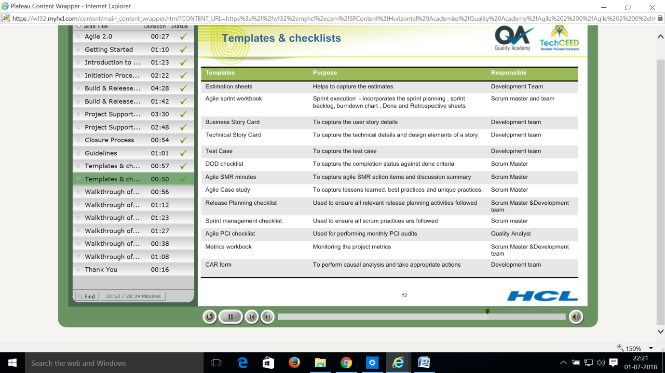

**IMPORTANT ARTIFACTS** – **WAYS OF WORKING DOCUMENT** – **Slide 13**

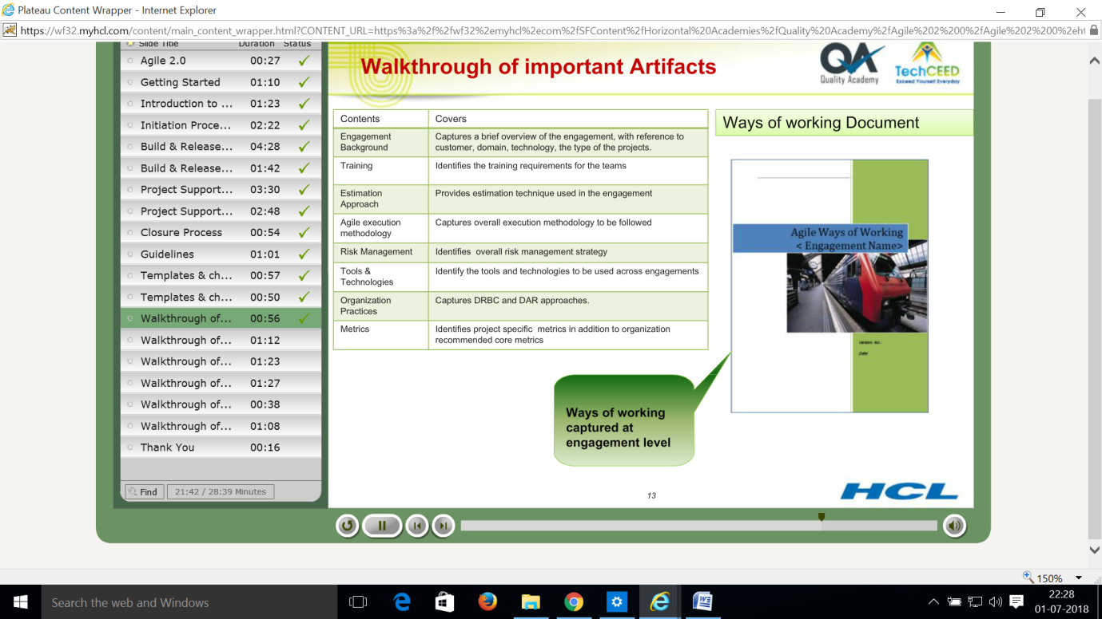

Important Artifacts - Agile Project Charter – Slide 14

Agile project charter - the project specific planning parameters – Scrum master

Prepared during project initiation and planning stage by scrum master Project specific information is captured

Details of stake holders

Project readiness

Ceremonies

Product testing strategy

Automation testing strategy and their frequency

Build scripting and scheduling the build

Configuration management plan

Deviations from standard agile processes

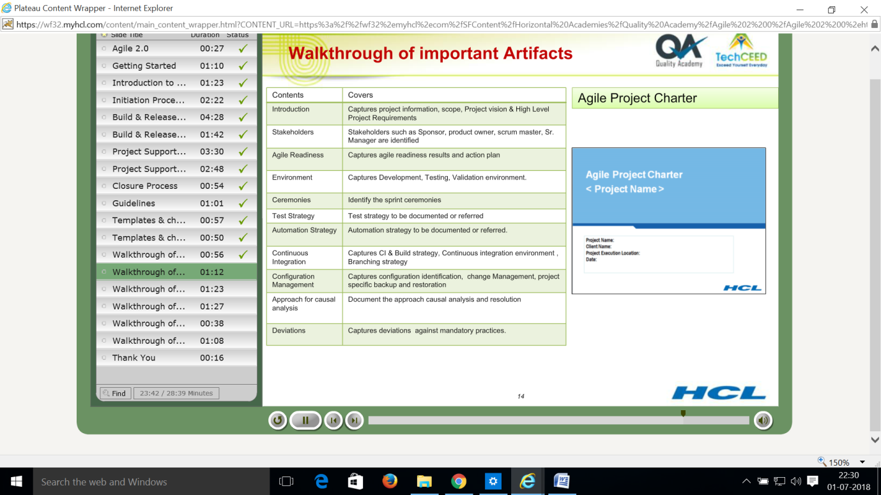

**Agile Applicability checklist and Agile readiness checklist - Slide 15**

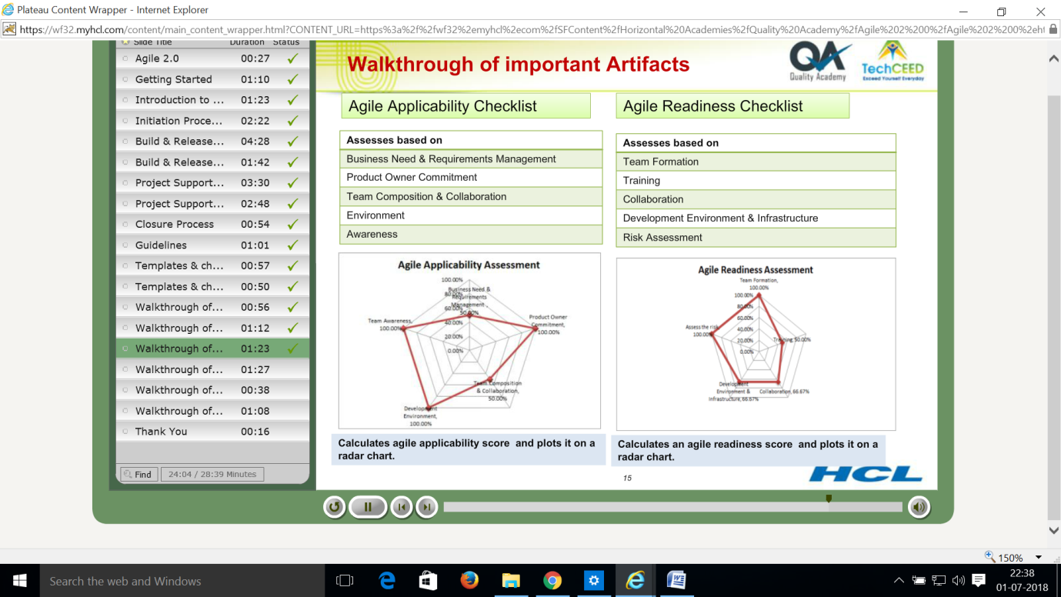

Agile project workbook and Metrics Workbook – Slide 16

**Agile project workbook contents -**

Product backlog

Estimation

Release planning

Product burn down

Resource plan

IT services plan

Training plan

Assumptions and dependencies

Impediments log

Action items

Traceability matrix

Risk management sheet

Story clarity index

**Metrics Workbook –**

User story acceptance

Velocity variation

Review effectiveness

Defect leakage

Defect removal efficiency

Defect density

Sprint stretch factor

Productivity

Cyclomatic complexity

Code coverage

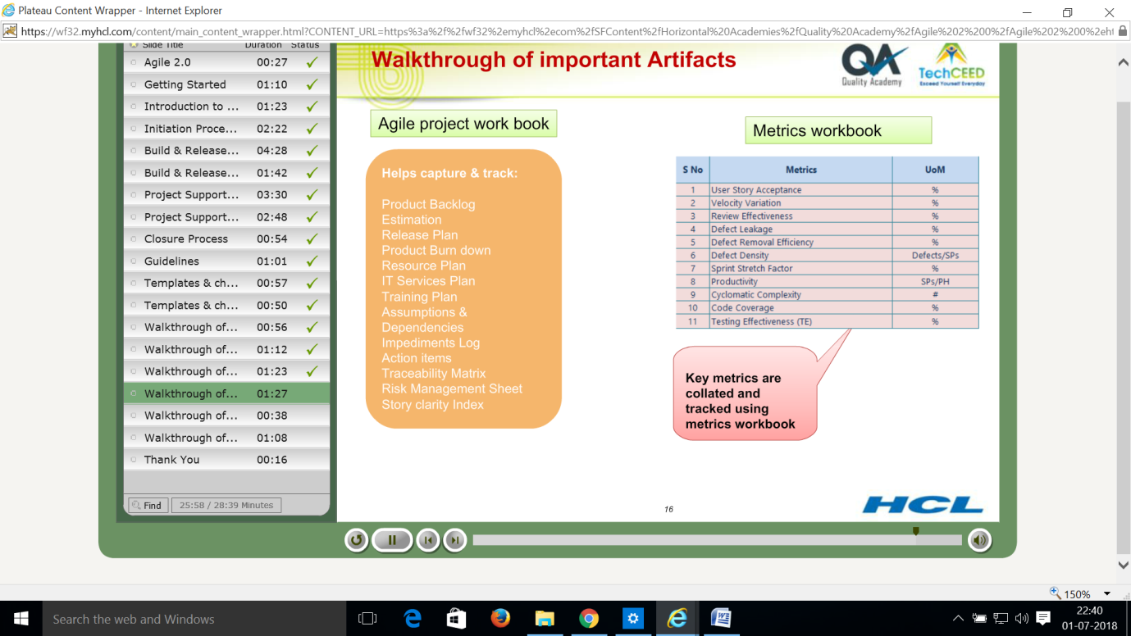

**Agile Sprint Work book – Slide 17**

Project information, planning, sprint backlog, burn down chart – ideal trend list, definition of done, Sprint retrospection summary, standard tasks list

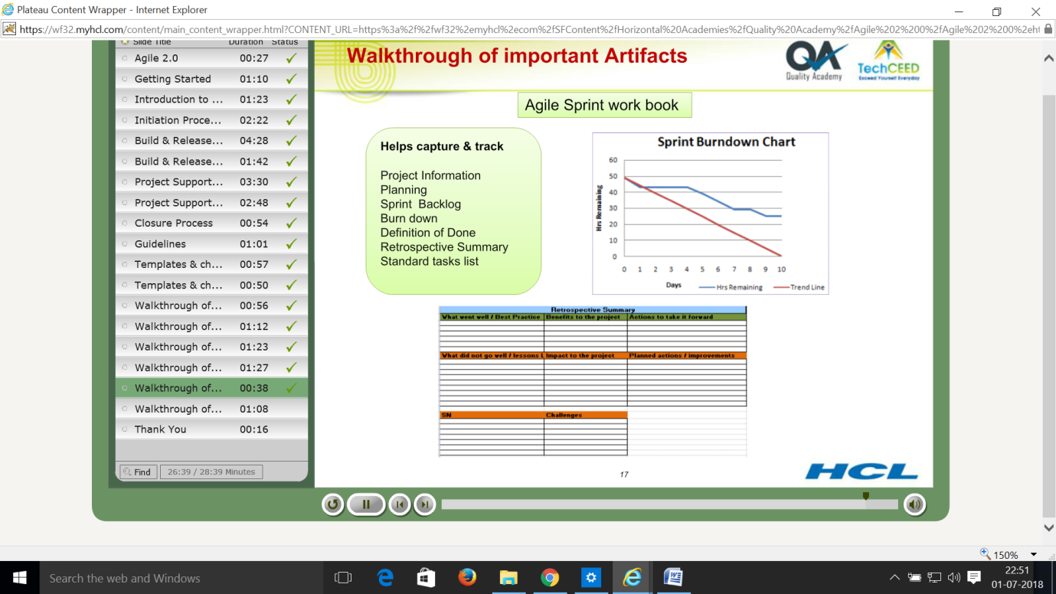

**Definition of Done checklist and Agile PCI checklist** – **Slide 18**

Definition of done checklist is used to verify the level of done for each story sprint before the demo by scrum master

**Agile PCI checklist –** Calculates the project compliance index and produces a project health status report.